Celtic Christianity
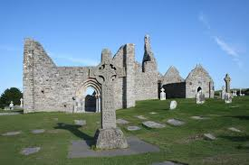
(based on a lesson from Working Out)
This lesson looks at some stories of Celtic Christianity in Ireland.
You need to know:
The Roman expansion through Europe began around 100BC, and all but the furthest western part of Europe gradually came under Roman rule. Ireland remained unconquered by the Romans and kept its Celtic culture and religion. As Christianity reached these areas the Celtic people brought a lot of their own culture into this new religion.
The Celtic Christian church was mainly based around monasteries. Most monasteries were founded in Ireland between the 5th and 7th centuries and were started by people who had visited and trained in monasteries in Scotland or Wales. Here are some monasteries founded in the 6th century. Are any of these near where you live?
Monastery
Monasterboice
Clonard
Derry
Clonfert
Lismore
Clonmacnoise
Bangor
Kildare
Search on the internet for a picture of the monastery in one of these places.
Those who lived in monasteries spent their time praying, studying the Bible, looking after the poor and keeping a farm. Some monks left and travelled as missionaries, Columba went to Iona in Scotland and founded a monastery there; Brendan is said to have travelled to Greenland and possibly North America. Other monks stayed in Ireland and decorated Bibles and religious books.
Look up some of these key words and write a definition of the word as you think it might relate to Celtic Christianity in Ireland.

Monk
Retreat
Hermit

Monastery
Cell

Saint Kevin

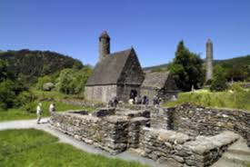
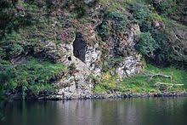
Saint Kevin is a famous Celtic Christian. It is thought that he was born in 498CE in West Wicklow. He became a priest and set out to find his own place of prayer or hermitage. He arrived in Glendalough, chose the area of the Upper Lake and settled on the south side of the foot of that lake in St Kevin’s Bed, an artificial cave about 9 metres above the level of the lake. This cave was originally a Bronze Age tomb. Kevin lived the life of a hermit for seven years, wearing only animal skins, sleeping on stones and eating very little. He prayed and spent his life as close to God and as close to nature as he could. People heard about Kevin and would come to see him. He often retreated to St Kevin’s Bed and pulled a ladder in behind him.
Many young men came to Glendalough wanting to live like Kevein. Although this wasn’t the life of peace he had planned, Kevin gave in and built a large hut where he led them in prayer. In time, Kevin’s hut became a famous monastery with a school, chapel and a house for sick people.
It is now a popular place with tourists.

Think about it and write….
The Celtic Christians had a deep sense of God being with them, especially in nature.
Why do you think this was so?
Do you think being a hermit was a good way of following Jesus? Why? Why not?
Do you think spending time in quiet is a good way of following God? Why? Why not?
Do you like being by yourself?

Find out about one of these other famous Celtic Christians and write a short factfile about them. St Brendan, St Columba or St Brigid.
FactFile:
Saint__________________________________
Dates__________________________________
Where s/he lived _________________________
Some reasons s/he is famous:
1

2

3
The Celtic High Cross
Over 200 High Standing Crosses were erected in Ireland between the 7th and 12th centuries. Two of the most famous still standing are this one at Monasterboice and one at Moone (on the next page).
The circle on the cross can be said to represent the sun (source of light/ heat and life) and eternity (as a circle has no beginning and no end).
The crosses were highly decorated, often with Bible stories. Many were located at spots where battles had taken place or where preaching had happened – just like the standing stones in early centuries in Ireland.
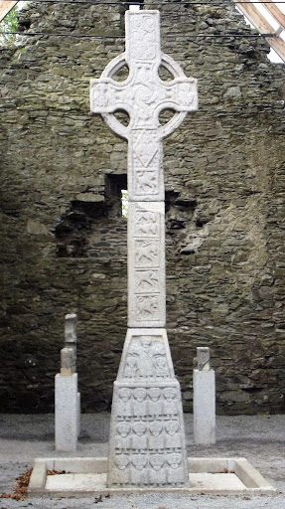
On a traditional high cross the east and west faces and sometimes the narrow sides too were decorated with Bible scenes. The west face usually has stories of Jesus with the crucifixion in the middle of the cross face, surrounded by the circle. The east face often has Old Testament stories (Adam and Eve, Noah’s Ark) and stories from the book of Revelation (the last book of the Bible).
The crosses were decorated with Celtic designs and knotwork.
Some crosses stood up to 4.5 m high.

Activity Design two sides of a Celtic cross. On one side include Bible stories from the Old Testament and on the other side choose stories from the NewTestament– you may have your own ideas or here are some suggestions and where to find them in the Bible if you want to check the story. You can search online by typing Bible Gateway International Children’s Bible and the reference beside the name into Google or another search engine.
Adam and Eve: Genesis 3:1-13; Noah: Genesis 6:9-22, 9:8-17; Isaac: Genesis 22:1-19; Joseph: Gensis 37:3-4; Moses: Exodus 2:1-10; Daniel: Daniel 6:16-22; Ruth: Ruth 1.
Birth of Jesus: Luke 2:1-7, Baptism of Jesus: Luke 3:21-22; Jesus heals: Luke 4:38-40; Jesus feeds 5000: Luke 9:10-17; Jesus calms storm: Luke 8:22-25; Jesus and Zacchaeus: Luke 19:1-9; Crucifixion of Jesus: Luke 23:36-39; Resurrection of Jesus: Luke 24:36-39.
Remember the Crucifixion story goes in the centre of the New Testament side.
Don’t forget the Celtic knotwork designs too. There are lots of examples on line.
God to enfold me
God to surround me
God in my speaking
God in my thinking

God in my sleeping
God in my waking
God in my watching
God in my hoping.
(Carmona Gaelacha)
