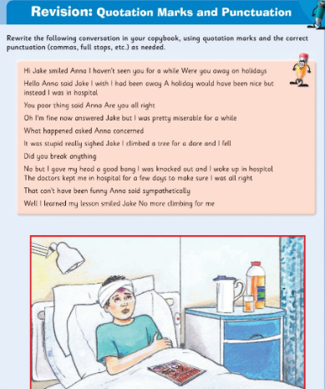
Remember to start a new line each time a new person starts to speak!

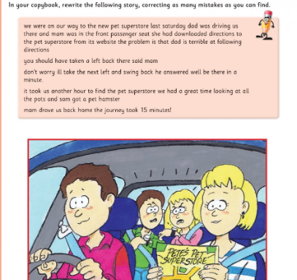
If you have time, try this one in your copy (or print out and use a red pen to put in all the corrections. It is missing capital letters, quotation marks, fullstops and apostrophes!

