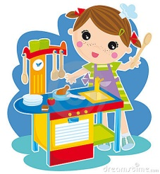
Maths at home
1
First Stop: The Kitchen
Q.1 How many presses in the kitchen? _______________.
Q 1 b Multiply this by 14 here.

Q.2 Look through the food cupboards Can you:
(a.) find two things that are 400g: _______________.
(b.) find one thing that is 1 kg: _______________.
(c.) what is 2,400g + 400g + 1.6 kg? _________________ g.

Q.3 Using your hands guess and then measure the length of the kitchen table with a ruler.
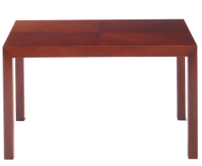
Guess: ___________cm.
Measure: ___________cm.
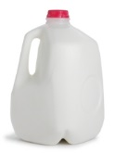
Q.4 (a.) Approximately how many litres of milk are in the fridge? ____________.
(b.) If a cup of hot chocolate need 200ml of milk. how many cups of hot chocolate can you make? ____________.

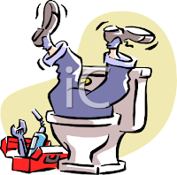
Second Stop: The Bathroom
2

Q.1 Look at all your bottles of shampoo. Add them together. How much shampoo do you have in mls? ____________ mls

Q.2 If each roll of toilet paper costs 70c, how much did all the toilet paper in your bathroom cost in euros? €_________.

Q.3 Find a jug and a cup. Guess and then measure how many cups of water fill the jug.
Guess: _____________
Answer: _____________

Q.5 Name and draw four 3D shapes you can see in the bathroom:

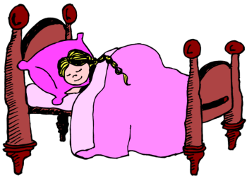
Third Stop: The Bedroom
3

Q.1 (a.) What time did you get up at today? ________.
Write this time in 24hr time: _________________
(b.) What time was it 3 ½ hour earlier? ________.
(c.) Draw this time on the clock face:
Q.4 Using your hands guess and then measure the height of the door with a ruler in cm /m.
Guess: ____________.
Measure: ____________.

Q.5 One of your coats cost €65 before the sale when there was 15% off everything. Work out here what you paid for this coat!

Q.5 Using Lego, build two 3D shapes! Name them.
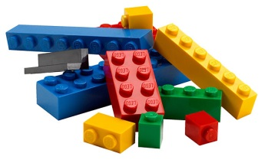
A ___________ and a ____________.
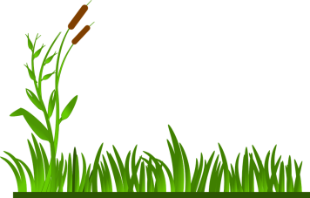
Fourth Stop: The Garden
4
Q.1 (a.) I have 4 packets of tomato seeds. Each packet has 25 seeds in it. How many seeds do I have? ____________.
(b.) If each seed grows a tomato plant, and each tomato plant grows five tomatoes, how many tomatoes will I have? ____________.
(c) If I sold each tomato for 15c, how much money would I make?
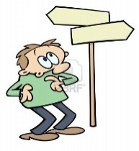
Q.4 (a) If the back door of the house faces west, what direction would be:
90 degrees clockwise.___________
270 degrees clockwise ___________
180 degrees anti-clockwise _____________
90 degrees anti-clockwise _______________

Q.5 Find and draw two examples of symmetry in the garden!

Font used: BAB HollyPrint from https://www.teacherspayteachers.com/Store/Bugs-And-Beaches

