The Holy Spirit (log-on and on-line)
Sunday 31 May is known as Pentecost – the day the Church thinks of when the Holy Spirit came upon the disciples of Jesus. This week’s lesson includes the story of that event and thinks about how the events of that day changed the disciples from hiding and being scared to becoming the people who formed the early Christian church.
Session 1
Discuss: Jesus had ‘ascended’ into heaven – his disciples were really missing him. You are probably missing some people from your school at the moment. Write their names in this box and try to find a way to talk to them this week.
We also may miss people who have moved house to live somewhere else and we miss people who have died.
Missing You

Peter and the other disciples really missed Jesus. Remember, they had given up their jobs and had spent a number of years travelling with Jesus and working to support him. Now he had gone and they were unsure what to do next. Jesus had told them to go to Jerusalem to wait. They were altogether in a house and were probably talking about everything that had happened in the past few years and especially about Jesus’ death and resurrection (when Jesus rose from the dead). Remember they had seen Jesus being killed and they were probably a bit scared for their own safety too.

Take a few minutes to script a conversation between two of the disciples.
Peter

Andrew

Peter

Andrew

Peter

Andrew

Peter

Andrew

Peter

Andrew

Peter

Andrew

Peter

Session 2. This is what happened that day in Jerusalem : Acts 2:1-4
When the day of Pentecost came, they were all together in one place. Suddenly a noise came from heaven. It sounded like a strong wind blowing. This noise filled the whole house where they were sitting. They saw something that looked like flames of fire. The flames were separated and stood over each person there. They were all filled with the Holy Spirit, and they began to speak different languages. The Holy Spirit was giving them the power to speak these languages.
There were some religious Jews staying in Jerusalem who were from every country in the world. When they heard this noise, a crowd came together. They were all surprised, because each one heard them speaking in his own language. They were completely amazed at this. They said, “Look! Aren’t all these men that we hear speaking from Galilee? But each of us hears them in his own language. How is this possible? We are from different places: Parthia, Media, Elam, Mesopotamia, Judea, Cappadocia, Pontus, Asia, Phrygia, Pamphylia, Egypt, the areas of Libya near Cyrene, Rome (both Jews and those who had become Jews), Crete and Arabia. But we hear these men telling in our own languages about the great things God has done!” They were all amazed and confused. They asked each other, “What does this mean?”
But others were making fun of them, saying, “They have had too much wine.
But Peter stood up with the 11 apostles. In a loud voice he spoke to the crowd
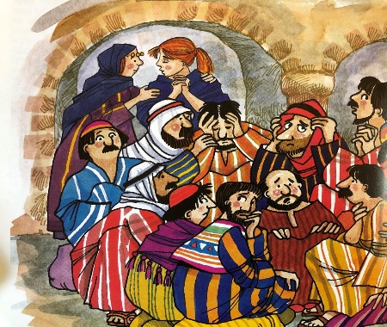
Watch two slightly versions of the story here: https://www.youtube.com/watch?v=jNiApXVR9go and https://www.youtube.com/watch?v=xz8K1upi0nE
These are two versions of the story.
What similarities did you notice between the stories?
What differences did you notice between the stories?

If you were creating a film version of that story what are the key parts you think are essential to the story?

1.

2.

3.

4.

Session 3

After the events you read about in Session 2, Peter spoke to all the people that had gathered to see what was going on. He told them the story of Jesus and told them that they too could be part of the family of believers.
The Bible says that ‘Then those people who accepted what Peter said were baptized. About 3,000 people were added to the number of believers that day. They spent their time learning the apostles’ teaching. And they continued to share, to break bread, and to pray together’. (Acts 2)

Imagine you were a reporter in Jerusalem that day, reporting on the harvest festivities. You interviewed some of the people who saw Peter and the disciples. Write an article for the newspaper. You can refer back to the stories printed here or read the whole story, including Peter’s talk at https://www.biblegateway.com/passage/?search=Acts+2&version=ICB

Session 4
As people from other countries heard the Good News of Jesus, so they were able to spread the gospel message to their own country and further afield. You may have read the story of Paul who did just that.

The story of Pentecost is also really the story of the beginning of Christianity as a world religion. In 2015 there were 2.3 billion Christians in the world (a third of the world’s population).

Look at https://en.wikipedia.org/wiki/Christianity_by_country and try and find the answers to fill in this table. Look at the third column from the left to see the %Christian in these countries. You could also draw the flag into the table.

Flag | Country | % Christian
 | Belgium
 | El Salvador
 | Greece
 | Nepal
 | Zambia
 | Morocco
 | Indonesia
 | Libya
 | Poland
 | Ireland

(note these are 2015 statistics and so may have changed since then in some countries)

Which country had the highest percentage of people who are Christian?
Which country had the lowest percentage of people who are Christian?

Look at the table again. Can you guess or find out what the main religion is in the countries with low percentages of people who are Christian?

Finally – if you are still figuring out what the Holy Spirit is, and it is sometimes hard to understand, then watch this video clip spoken by a Christian explaining what she believes about the Holy Spirit. https://request.org.uk/life/beliefs/christianity-basically-the-holy-spirit/

Prayer: The grace of our Lord Jesus Christ and the love of God
and the fellowship of the Holy Spirit be with us all, evermore. Amen.

Go raibh grásta ár dTiarna Íosa Críost, agus grá Dé, agus cumann an Spioraid Naoimh linn go léir. Áiméan.

