Promises of Hope
(suitable for 4th-6th class)
There are many Bible stories that have a theme of hope and lots of them are in the Follow Me books. This week’s lessons will include some stories you know already but will help us think about hope.
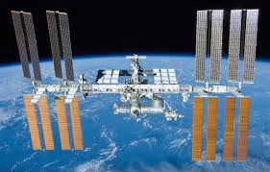
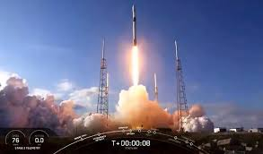
Did you watch the space ship launch from Florida on 27 May? It was a successful launch and two astronauts travelled for 19 hours to the International Space Station. What stories from Earth do you think the two astronauts brought to the crew already on the International Space Station? How do you think they described what life is like on Earth at the moment?
Take a few minutes to write down in less than 100 words what life is like on Earth at the moment.

………………………………………………………………………………………………………………………………………………….
…………………………………………………………………………………………………………………………………………………
………………………………………………………………………………………………………………………………………………….
As well as hoping for a successful trip and time in space the astronauts have hopes for how life will have changed on Earth after their planned 110 days working on the International Space Station. What hopes do you think they will have?
……………………………………………………………………………………………………………………………………………..
………………………………………………………………………………………………………………………………………………..
You can search online for photos of Ireland taken from the International Space Station. With the fine weather we have had recently there are some lovely images to be seen.
Ever since the beginning of time, people have looked into Space and wondered about everything they could see and also wondered about what was beyond their sight. One of the writers of the Psalms in the Bible wrote it like this:
Psalm 8
I look at the sky and I can see how amazing God is. He made the sun for daytime and the moon and stars for night time.
He is greater than the whole world.
I am so small compared with God. Why does he care about me?
Thank you God for making the sun and the moon and the stars. You are so great, God. Thank you for loving me.

Can you write your own version of Psalm 8? You might imagine you are looking out of the International Space Station or you could look out your window at the natural world and reflect on one aspect of it – you could choose the trees/ the mountains/ the sea. Just like the writer of the Psalm, think about the size of God’s creation and how small we are. Use the template below:

I look at the …………….. and I can see how amazing God is. He made the …………………
………………………………………………………………………………………………………………………………………………..
………………………………………………………………………………………………………………………………………………..
He is greater than the whole world.
I am so small compared with God. Why does he care about me?

Thank you God for making the ……………………………………………………………………………………
You are so great, God. Thank you for loving me.

Two stories from Genesis in the Old Testament part of our Bibles have a focus on the sky and on hope. They also are about special promises called Covenants – promises made between God and his people.
Story 1
First we will read about Abraham. God promised him as many descendants as the stars in the sky. What is a descendent?
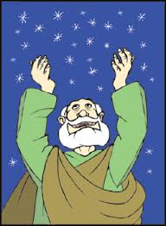
Watch the story: https://www.youtube.com/watch?v=rYmBrvFplCQ
God made a promise to Abraham. How did Abraham respond?
What do you think Abraham thought about God’s promise?
Can you think of another story in the Bible where God spoke to a person and gave them a task or made a promise?
………………………………………………………………………………………………………………………………………
Abraham did have a son who he named Isaac, and Abraham is known as the Father of the Israelite people.

Genesis 15:
Then God led Abram outside. God said, “Look at the sky. There are so many stars you cannot count them. And your descendants will be too many to count.”
Next time you look at the night sky – think of that promise to Abraham. He had hope after that – hope of a child and hope in God’s promise. Do you think it was hard for him to hope when things looked impossible?

…………………………………………………………………………………………………………………………………..

Story 2.
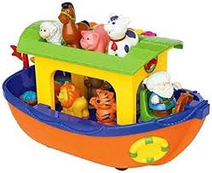
The second story is one you also know well. Did you have a Noah’s Ark to play with, like this, when you were little?
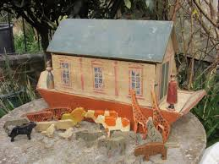
This is made of plastic but your greatgrandparents might have played with a wooden Noah’s Ark like this. This one is about 150 years old. Over 100 years ago in some homes these Noah’s Ark toys were seen as Sunday toys – Sunday was very different then – no shops, no sports activities, very few games and this toy – a story from the Bible, was seen as a very suitable toy for children to play with on Sundays.

Watch the story: https://www.youtube.com/watch?v=4pKzhwOtMIQ
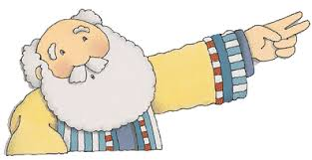
Chat or write:
Did you like the story? Why? Why not?
What kind of person was Noah? Write some words to describe him in the circle.
What was the key moment in the story?
What do you think Noah’s friends
thought of him?

If this story was taking place today
what headlines might have been on
newspapers or on social media?

………………………………………………………………………………

……………………………………………………………………………………………………………………………………………………………

When do you think Noah had to hope in that story?
The story of Noah
God was very angry. When he looked at the beautiful world he had made, he saw the bad things people were doing to it and to each other. It made him very sad. He decided the world needed a fresh start!
He had noticed one good man and his family and he decided he would ask him to help. The man was called Noah.
God told Noah to build a boat. A boat big enough to take his family and two of each of the different animals in the world.
When Noah had finished building the boat, and filling it with animals, the rain started. It poured and poured for day after day until one day it stopped at Mount Ararat.
Noah was full of hope that there would be land. He sent out a dove. When it came back with a leaf in its beak, Noah was full of hope. He waited a few days and sent the dove out again. When it didn’t return Noah know that there was land again and that the bird had found a home.
When the floods had gone down, Noah and his family stepped on to dry land. Overhead there was a beautiful rainbow, seven bands of light.
God made a special promise with Noah, called a covenant. He promised never to flood the world again and said the rainbow was a reminder of that promise.
And for thousands of years, the rainbow in the sky has reminded people to have hope, hope that after the rain and the hard times, sunshine will come. (Genesis)
Do you think there was a time that he nearly ran out of hope? When might that have happened?
Can you think of some things that people your age hope for? Write them in this box. (Choose 7) Then write a sentence about each hope onto the rainbow.
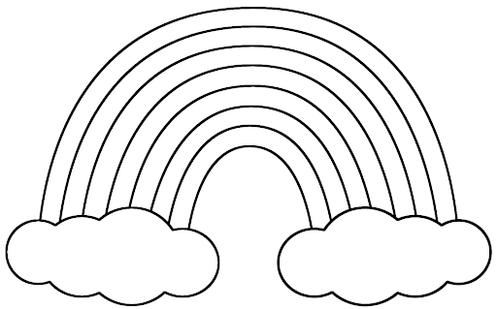

.
Jesus taught his followers that God loves and cares for each of them. Even when things are sad or boring or you are feeling grumpy or sick, Jesus taught that God loves and cares for you. That’s a good news story and one that is full of HOPE.
The HSE has taken the picture of the rainbow as a sign of hope for the times we are living in today. The words ‘ hold firm’ and the rainbow are also all about hope for us at the moment.

Use the template of the rainbow on the next page or make your own.
For each band of colour write a hope you have:
Red: My hope for myself is…………….
Orange: My hope for my family is …………….
Yellow: My hope for my school is……………….
Green: My hope for my town/ village/ neighbourhood is ………
Blue: My hope for Ireland is …………….
Indigo: My hope for the world is…………….
Violet: My other hopes are………………………..

A prayer for our school:
God bless the people of our school,
In everything we do
And may the love you show to us,
Be always shining through. Amen.
(Carlow NS)

