K.N.S. Newsletter
September 2023
Dear parents / guardians,
Welcome back! We hope everyone had a lovely summer. We welcome all our new Junior Infants to Kilcommon NS: Cillian, Cuileann, Karen, William, Simone, Iris, Hector, Olivia & Louis. We look forward to getting to know them all this year.
Staffing: Just before the holidays, the school had heard that Mrs Katus would be retiring. She has been on leave for the last couple of years and we all send our best wishes to her for many happy years of retirement. We thank her for her many years of hard work in Kilcommon NS. Happy retirement! We welcome Ms Kendra Kiersey to our teaching staff. Ms Kiersey will teach 1st / 2nd classes and we wish her many happy years teaching in Kilcommon.
We currently have no Tús workers in the school - caretaker or school assistant. Tús are currently trying to recruit for Kilcommon NS. A copy of the advertisement has been shared on seesaw so if you are interested, or if you know anyone else who might be interested and eligible, please contact khennessy@wicklowpartnership.ie
Website: Our website address has changed. The new address is kilcommon.weebly.com The activity gallery tab has lots of details of recent school activities. Check it out - It is updated with photos and information throughout each term. Newsletters and policies are also shared on the website.
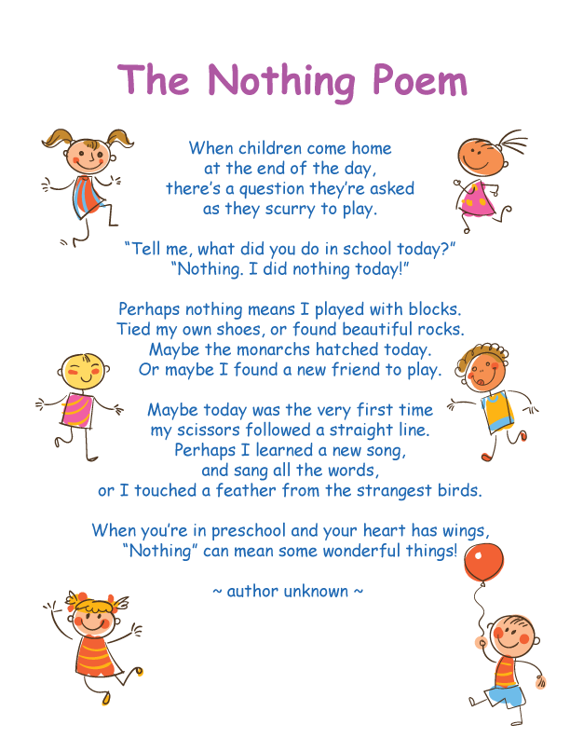
B.O.M news : Our Board of Management meets each term. We were delighted to have had a new bike shelter installed over the summer holidays. The front gate has been altered to allow bicycles to enter. Interviews were held in August and we were delighted to appoint Ms Kendra Kiersey as a permanent member of staff. The board regularly reviews policies. When reviewing policies, we value parent input and policies will be available to view on our school website, as part of the review process. Please check the website policy page regularly and all suggestions should be emailed to principalkilcommonns@gmail.com. We thank all members of the board for their hard work and commitment over the last four years. Board of Management elections will take place later this term. Information on the procedures will be shared nearer the time.
We include lots of general information in this September newsletter, as we welcome new families who are new to procedures to the school. However, I hope this information is also helpful as a reminder for existing school families. Please contact me if you have any further questions.
Looking forward to a great year ahead.
Melanie

M.M. Childcare: This ‘before-school and after-school programme’ runs before and after school each day this term. Queries to Maude Moore 089485699 or to mmchildcarekilcommon@gmail.com. Bookings can be made weekly, or on-going bookings can also be arranged, avoiding the requirement for weekly booking. Due to leader / pupil number requirements, last minute/ late bookings to leader (via the Whatsapp number above) are only accepted in special circumstances.
NB This service runs on school grounds, but independently of the school, and all bookings and payments should be made directly to the tutor.
Introduction Meetings with class teachers
- Junior Infant Parents Friday 15th September, 11.30am, KNS
- 1st/2nd class Zoom meeting Tues 26th Sept, 7.00pm (with Ms Kiersey)
- 3rd/4th class Zoom meeting Tues 26th Sept, 7.45pm (with Ms Stanley)
- 5th/6th class Zoom meeting Tues 26th Sept, 8.30pm (with Mrs Pardy)
These meetings provide an opportunity for teachers to explain some class procedures for the school year along with information on literacy, numeracy & homework. Zoom links will be shared with all families nearer the time.
P.T.A.: Our PTA AGM will be held shortly. The date will be shared, once finalised. We encourage everyone to consider attending to show support for this association which facilitates and encourages communication and a positive effective partnership between parents and school. New members are always very welcome!
Funds generated from PTA activities have been hugely beneficial over the past couple of years and have contributed to outdoor developments, music programmes, field trips, drama, visiting tutors, classroom resources and more!

AGM: Our school AGM will be held on Thursday 16th November, 8pm. Agenda: opening prayer, minutes, matters arising, finances & principal’s report, closing prayer. Please contact Mrs Hadden if you would like anything added to the agenda by Friday 10th November. Thank you.

Parent-Teacher Meetings: These will be held with all teachers after school during the week starting Mon 20th November. More details and timetable nearer the time.
Swimming: Swim lessons for all pupils has been arranged in Arklow and they will run for six weeks from Friday 22nd September for 1st, 2nd, 5th & 6th classes. The cost for lessons will be added to Aladdin online e-payments (see below). Swimming lessons for other classes will take place later this term. Lesson costs are based on pool hire, bus and instructors.
Parents may join at the pool, if wished, however only vetted parents may enter the changing areas..
Aquatics is part of the school curriculum and we hope to have all pupils swimming. However, due to supervision disruptions, pupils not swimming this year will need to travel on the bus to the pool with their class. Thank you in advance for your understanding.
Pupils should bring a swimsuit, named hat, towel, swim socks (optional). To help younger pupils prepare, please start now - Practice drying and getting fully dressed independently after showers/ baths at home.
General Information
Books: Reminder! All textbooks, readers, copybooks etc have been funded by the Department this year and they have been arranged by the school and are ready for the first day of term. Pupils only need their lunchbox, drink bottle and pencil case on the first day of school.
Uniform: Please ensure jumpers and coats are all clearly named.
Lunch boxes: Our school has a healthy eating policy to which we encourage all families to adhere as this makes it much easier for everyone. We are trying to operate no waste lunches. Any wrappers etc will be put back in lunchboxes and brought home.
Reminder - Friday is a treat day (No family size bars or large sweet bags please!) and lots of healthy food on Fridays is still encouraged!
School Times: This year, the school gate will open at 9am. School will start straight away, so please try to arrive as close to this as possible. A member of staff will open the gate at 9am. NB Anyone arriving after 9.15am should come to the front door instead - please try to avoid this though, as it is disruptive on a teacher leaving class to open the door, and on your child who often misses early morning explanations etc. Thank you.
Car Parks: The school and church car parks may both be used by families and they can be very busy, morning and afternoon. Please drop off and collect pupils from the school gates. For safety, do not ask pupils to walk unattended to cars. Do not park in the bus parking spaces. Pupils who walk home, occasionally or regularly, should have written permission for this.
Access: All access to the school is down school lane. Please - no entry at any point via the church lane gate at the service station. Both lanes however may be used to exit (However, if you park in the church grounds, please exit only using church lane - to avoid collisions, do not re-enter the school carpark /lane). Please be cautious reversing and drive slowly. Please share this information with all who drop off or collect from the school.
Access to the school building: All adults who need to enter the school building, at any stage of the day, are asked to enter via the front door of the school only. Please do not come to the back door of the school for this reason.
All mid-day school collections for appointments should also be from the front door of the school. Thank you for supporting us in this, as both Safety and Child Protection guidelines require us to be aware of parents /visitors who are in the building at any time.
Home school communications: We remind everyone to update any changes to your emails and phone numbers during the year with the school office.
If you have questions or concerns during the year, we ask that your child’s teacher should be your first port of call. Please contact teachers to arrange a suitable time for a meeting and to arrange follow up meetings. Contact details for all teachers can be found below. We strongly believe that an open working relationship amongst staff and with families will provide a happy and excellent education for your children. If there is a difficulty along the way, working positively together will help solve matters quickly and help ensure a positive outcome.
- School phone 0402-38192. A message may be left and our secretary Helen generally works Mondays, Wednesdays & Fridays, should you need to speak with her.
- Seesaw App (recommended as seen daily, but please note that in school hours messages may not be seen until the end of the day). Send a message directly to your child’s teacher and we will reply or call you as soon as we can. Messages after 4.30pm may not be replied to until the following morning.
- Office Email: : info@kilcommon.net (secretary & principal access)
- Mrs Workman: junior@kilcommon.net
- Ms Kiersey: 1and2@kilcommon.net
- Ms Stanley: 3and4@kilcommon.net
- Mrs Pardy: 5and6@kilcommon.net
- Mrs Hadden: principalkilcommonns@gmail.com
Seesaw: (a) It is essential that at least one parent in each family downloads this app. Please contact the school if you need your family code or if you have difficulty logging on to the app.
NB Seesaw will be used regularly to communicate with parents as Seesaw messages are free and we are charged for the regular school text messages. Please make sure that you have notifications on for Seesaw or you may miss important notes and messages from the school and your child’s teacher throughout the year. Please communicate using the app - NB Do not reply to the seesaw email as teachers do not receive these messages.
I.T: We ask that all pupils from 1st – 6th classes should have their own named earphones / headset in school everyday for use with our i-pads and chromebooks.
Policies: Our school policies for Child Protection and Anti-bullying are available on the school website www.kilcommon.net. These are reviewed each spring by the Board of Management. NB Our Designated (Child Protection) Liaison Officer (DLP) is Mrs. Hadden. In the absence of Mrs Hadden, Miss Stanley is the acting Deputy Liaison Officer.
Medication: For all occasional, short-term and long-term medication please see our ‘Administration of Medicines’ policy which is available on the school website, or contact the school office for advice or a copy of our policy. Some key points include:
- No short-term medications may be given in school or self administered by pupils without written permission ( this includes lozenges etc).
- Regular and long term medications (epi-pens, inhalers, anti histamine etc) also require completion of forms. NB All of these medications are kept in the staff room. Regular and long-term medications require extra forms to be filled in by parents.
Absences from School: We promote positive and good school attendance. We understand that many absences are unavoidable. Our roll call is done online and this year it will be officially marked at 10 am. Pupils who are not on the school premises or who arrive after 10am (even if at appointments) must be marked absent, but late arrival times and early leaving times are also recorded on the system. If your child is absent: (a) Please send a message with reason to class teachers on seesaw / by email (b) if not possible, please complete one of the notes in the back of your child’s homework diary (Infants may send in a note in their child’s reading record booklet).
Absences must be input on our online system. If no reason is given for an absence, it must be recorded as ‘unexplained’. Please note that, by law, the names of any pupils who miss more than 20 days must be submitted on our reports to Túsla, Child and Family Agency ( hence the importance of reasons for absences). NB Our online system will automatically send you a text message when your child has missed 18 days. This text is a reminder for parents as the number of days can add up quickly!
Interesting fact: If your child misses 20 days they have missed over 10% of their school year’s education.
Payments / ePayments: Our school uses the Aladdin software service for administrative purposes and the ePayment system will give you access from an internet browser on your computer, phone or tablet to make secure payments to the school using your credit or debit card. Approximately once a term, you will receive a text/email message containing our payment-access link. NB This system allows you to tick items you are able to pay for on each transaction. A maximum of one or two transactions from a family a term is the ideal as the school pays a small fee on each transaction. As our local bank has closed its cash service to customers, we would ask that parents make every effort to pay through this Aladdin system as we can no longer lodge change. Thank you for your cooperation.
Voluntary contribution: Our school voluntary contribution helps cover the day-to-day costs of running the school. This contribution remains at €40 per family per term or €120 annually. Many thanks for your on-going support. Please note that, on the Aladdin system, voluntary contributions will register as unpaid until the full yearly contribution is paid.
Clothes Recycling: Clothes recycling will take place during the week before Halloween holidays. Start filling bags! Please leave bags for recycling by the front door. Use strong bags that are securely closed at the top. Clothes, shoes, sheets etc are all accepted but no cushions or duvets please.
Accident Insurance: Each year, accidental insurance for all children is organised with Ecclesiastical by the school. This is a 24hr cover, so pupils are also covered for accidents inside and outside of school hours. This cover costs €9.50 per pupil and this payment will be added to Aladdin school e-payments. No forms are necessary as we send on all names and addresses to the insurance company. Please note that it is the responsibility of parents to contact the school for information on how to follow up on a claim, whether inside or outside school hours.

K.N.S. School Calendar 2023 - 2024
This calendar is also available on our website - kilcommon.weebly.com .
A google calendar with school events throughout the year is also available on our website.
School reopens SI - 6th classes Wed 30th August 2023. (Junior Infants - Thursday 31st August)
J.I. Meeting Fri 15th Sept, 11.30am
School closure Mon 18th Sept - teacher inservice
Swim 1 Fri 22nd Sept - 1st, 2nd, 5th, 6th classes
1st/2nd class meeting Tues 26th Sept, 7pm
3rd/4th class meeting Tues 26th Sept, 7.45pm
5th/6th class meeting Tues 26th Sept, 8.30pm
Harvest thanksgiving. Fri 6th October, 7pm All Saints Carnew (Schools & parish joint event).
Clothes recycling week Mon 23rd - Fri 27th October (leave bags by front door)
Mid-term break. School closed Mon 30th Oct – Fri 3rd Nov (inclusive)
School AGM Thurs 16th Nov, 8pm
P.T Meetings Week starting Mon 20th Nov (Timetable will be shared later this month)
Christmas holidays School closure, Fri 22nd Dec, 12pm.
School reopens Mon 8th Jan, 2024
Bank Holiday School closed Mon 5th Feb
½ day Wed 14th Feb, 12pm. Staff meeting.
Mid -term break School closed Thurs 15th Feb & Fri 16th February (inclusive)
St Patrick’s Day School closed Mon 18th March
Easter School closed from Fri 22nd March,12pm.
School reopens Mon 8th April
½ day Fri 3rd May, 12 o’clock closure. Staff meeting.
May bank holiday School closed Mon 6th May
June bank holiday School closed Mon 3rd June
Sports Day Wednesday 12th June
Graduation Tuesday 18th June, 11am
Summer holidays School closed from Friday 21st June, 12pm.

