Some stories from Babylon
(based on lessons from Working Out)
How many words can you make from this king’s name?
NEBUCHADNEZZAR
Facts:
King Nebuchadnezzar was king of Babylonia.
The date is 605 BC.
The story is found in the book of Daniel in the Old Testament part of the Bible.
The ruined city of Babylon is in ruins and is located in Iraq, about 85 km south of Baghdad.

Setting the Scene: The Israelites had been defeated by the Babylonians and many people had been captured and taken to the capital city Babylon. There are a number of stories in the Bible about the time the Israelites spent away from home. They missed their homes and their families, their places of worship – the synagogue and the Temple. They had to find new ways of practising their religion – it had involved Sabbath, synagogue, the Temple, the festivals. Now there was a ‘new normal’. They had to figure out how to follow God in a new land and in new ways.
This is a bit familiar to us too – new ways of school, new ways of church, new ways of keeping fit, new ways of talking to our friends.

What things are you doing differently over the past few weeks? What is going well? What is not going well?..........................................
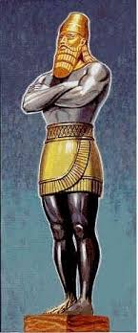
Story:
King Nebuchadnezzar was a powerful king and he set up a statue in the city to be worshipped. Jewish people knew it was against their religion to worship statues. Three men : Shadrach, Meshach and Abednego refused. See what happened: You can read the story here- https://www.biblegateway.com/passage/?search=Daniel+3&version=ICB
Or watch some young people tell the story here- https://www.youtube.com/watch?v=yjPirwPbypE

Check back to the Bible story (first link) to find the answers to these questions:
Shadrach. Meshach and Abednego
How high was the statue?
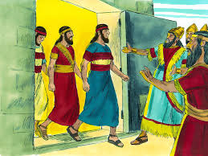
What musical instruments were played?
What happened when the king called the three men to him?
How hot was the furnace to be?
In what condition were the men when they came out?
What do you think happened?

Why do you think King Nebuchadnezzar changed his mind about worshipping God?

Why do you think the Jewish people were not allowed to worship statues?

Compose an email home to Jerusalem from one of the three men – tell your story in your own words. Or you could draw a comic strip of the story.

You could find out what your local church is doing at the moment to help people worship in these times when church services can’t take place. Just like Shadrach, Meshach and Abednego who worked hard to stay faithful to God in the story, churches in Ireland are working hard to make worship of God available to people. Search for your parish church on the internet and see what is going on.

Story 2. Daniel
Time had passed in Babylonia. Now the Persian Empire (Iran) had conquered Babylon. Their king was called Darius.
Daniel was one of the men who had come from Israel and he had been very successful – he was now an administrator and worked for the king. Unfortunately he wasn’t very popular with the other administrators and princes. His work was good, he was faithful and honest and they wanted to find a way to get rid of him.
You can read what happened here https://www.biblegateway.com/passage/?search=Daniel+6&version=ICB
You can watch the story here: https://www.youtube.com/watch?v=I8tXENptCSo This video clip is set in the times shortly after Jesus was alive and the family in the video clip is re-telling the stories from the Old Testament.
Check back to the Bible story and answer these questions:
What did the king’s law say?
What did Daniel do?
Persian law could not be changed so King Darius had no choice but to follow through on his threat. How did he feel, do you think?
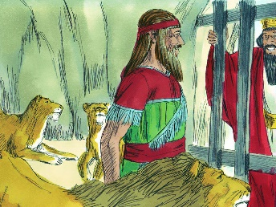
Describe the king’s reaction the morning after Daniel was thrown to the lions.
What do you think happened next?
Do you think Daniel should have prayed in secret rather than running the risk of being caught?
What do you think you would have advised Daniel to do?

Give both kinds of advice to Daniel:
Daniel – I think you should pray in public like you always do because
1
2
3
Daniel – I think you should stop praying in public because
1
2
3

Which argument do you think is strongest?

Eventually the Israelites did go back to Israel, they rebuilt their city of Jerusalem and the Temple there too. The stories of war and invasion continued and by the time we hear of the birth of Jesus several hundred years later, the country is under the control of the Roman Empire.

Freedom
There are lots of things we would like to be able to do at the moment but we can’t. That is hard for us. The stories we looked at were about people who were not allowed to pray to or worship their God. In some countries in the world it is still dangerous to openly be a Christian.
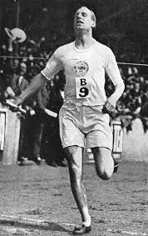
The stories this week have been about standing up for beliefs.
Have you heard of Eric Liddell? Find out how he stood up for his beliefs in 1924.
What did he refuse to do?
What record did he break?

You might like to read or say this prayer:
In darkness and in light, in trouble and in joy, help us to trust your love, to serve your purpose and to praise your name; through Jesus Christi our Lord. Amen (Church of Ireland Book of Common Prayer, 2004)

If you have time here is a full video of the two stories you have looked at this week. It is 25 minutes long.
https://www.youtube.com/watch?v=MqJl0dzYYuA

© JW 2020

